# System Implementation & Test

## Introduction

### Overview

This section describes the approach and methodologies used by group to plan, organize and manage the testing of MIC system. It provides in the detail all necessary information about the implementation and testing procedure of the system included test plans, test cases, test result, test environments, pass/fail criteria and risks estimations as well as a checklist to cover all possible cases.

### Test Approach

* Goal: Test all features in the whole MIC system based on the core flow.
* Method: black-box testing
* Technique: check list

The testing for this project will consists of Integration System test level. Testing the program which was integrated and as a complete system to ensure that the software requirements have been met.

* Integration testing would be performed by all member of team and approved by team leader.
* System testing is focused on assessing the system’s reliability. This process is concerned with finding errors that result from unanticipated interactions between components and component interface problems.

## Database Relationship Diagram

### Physical Diagram

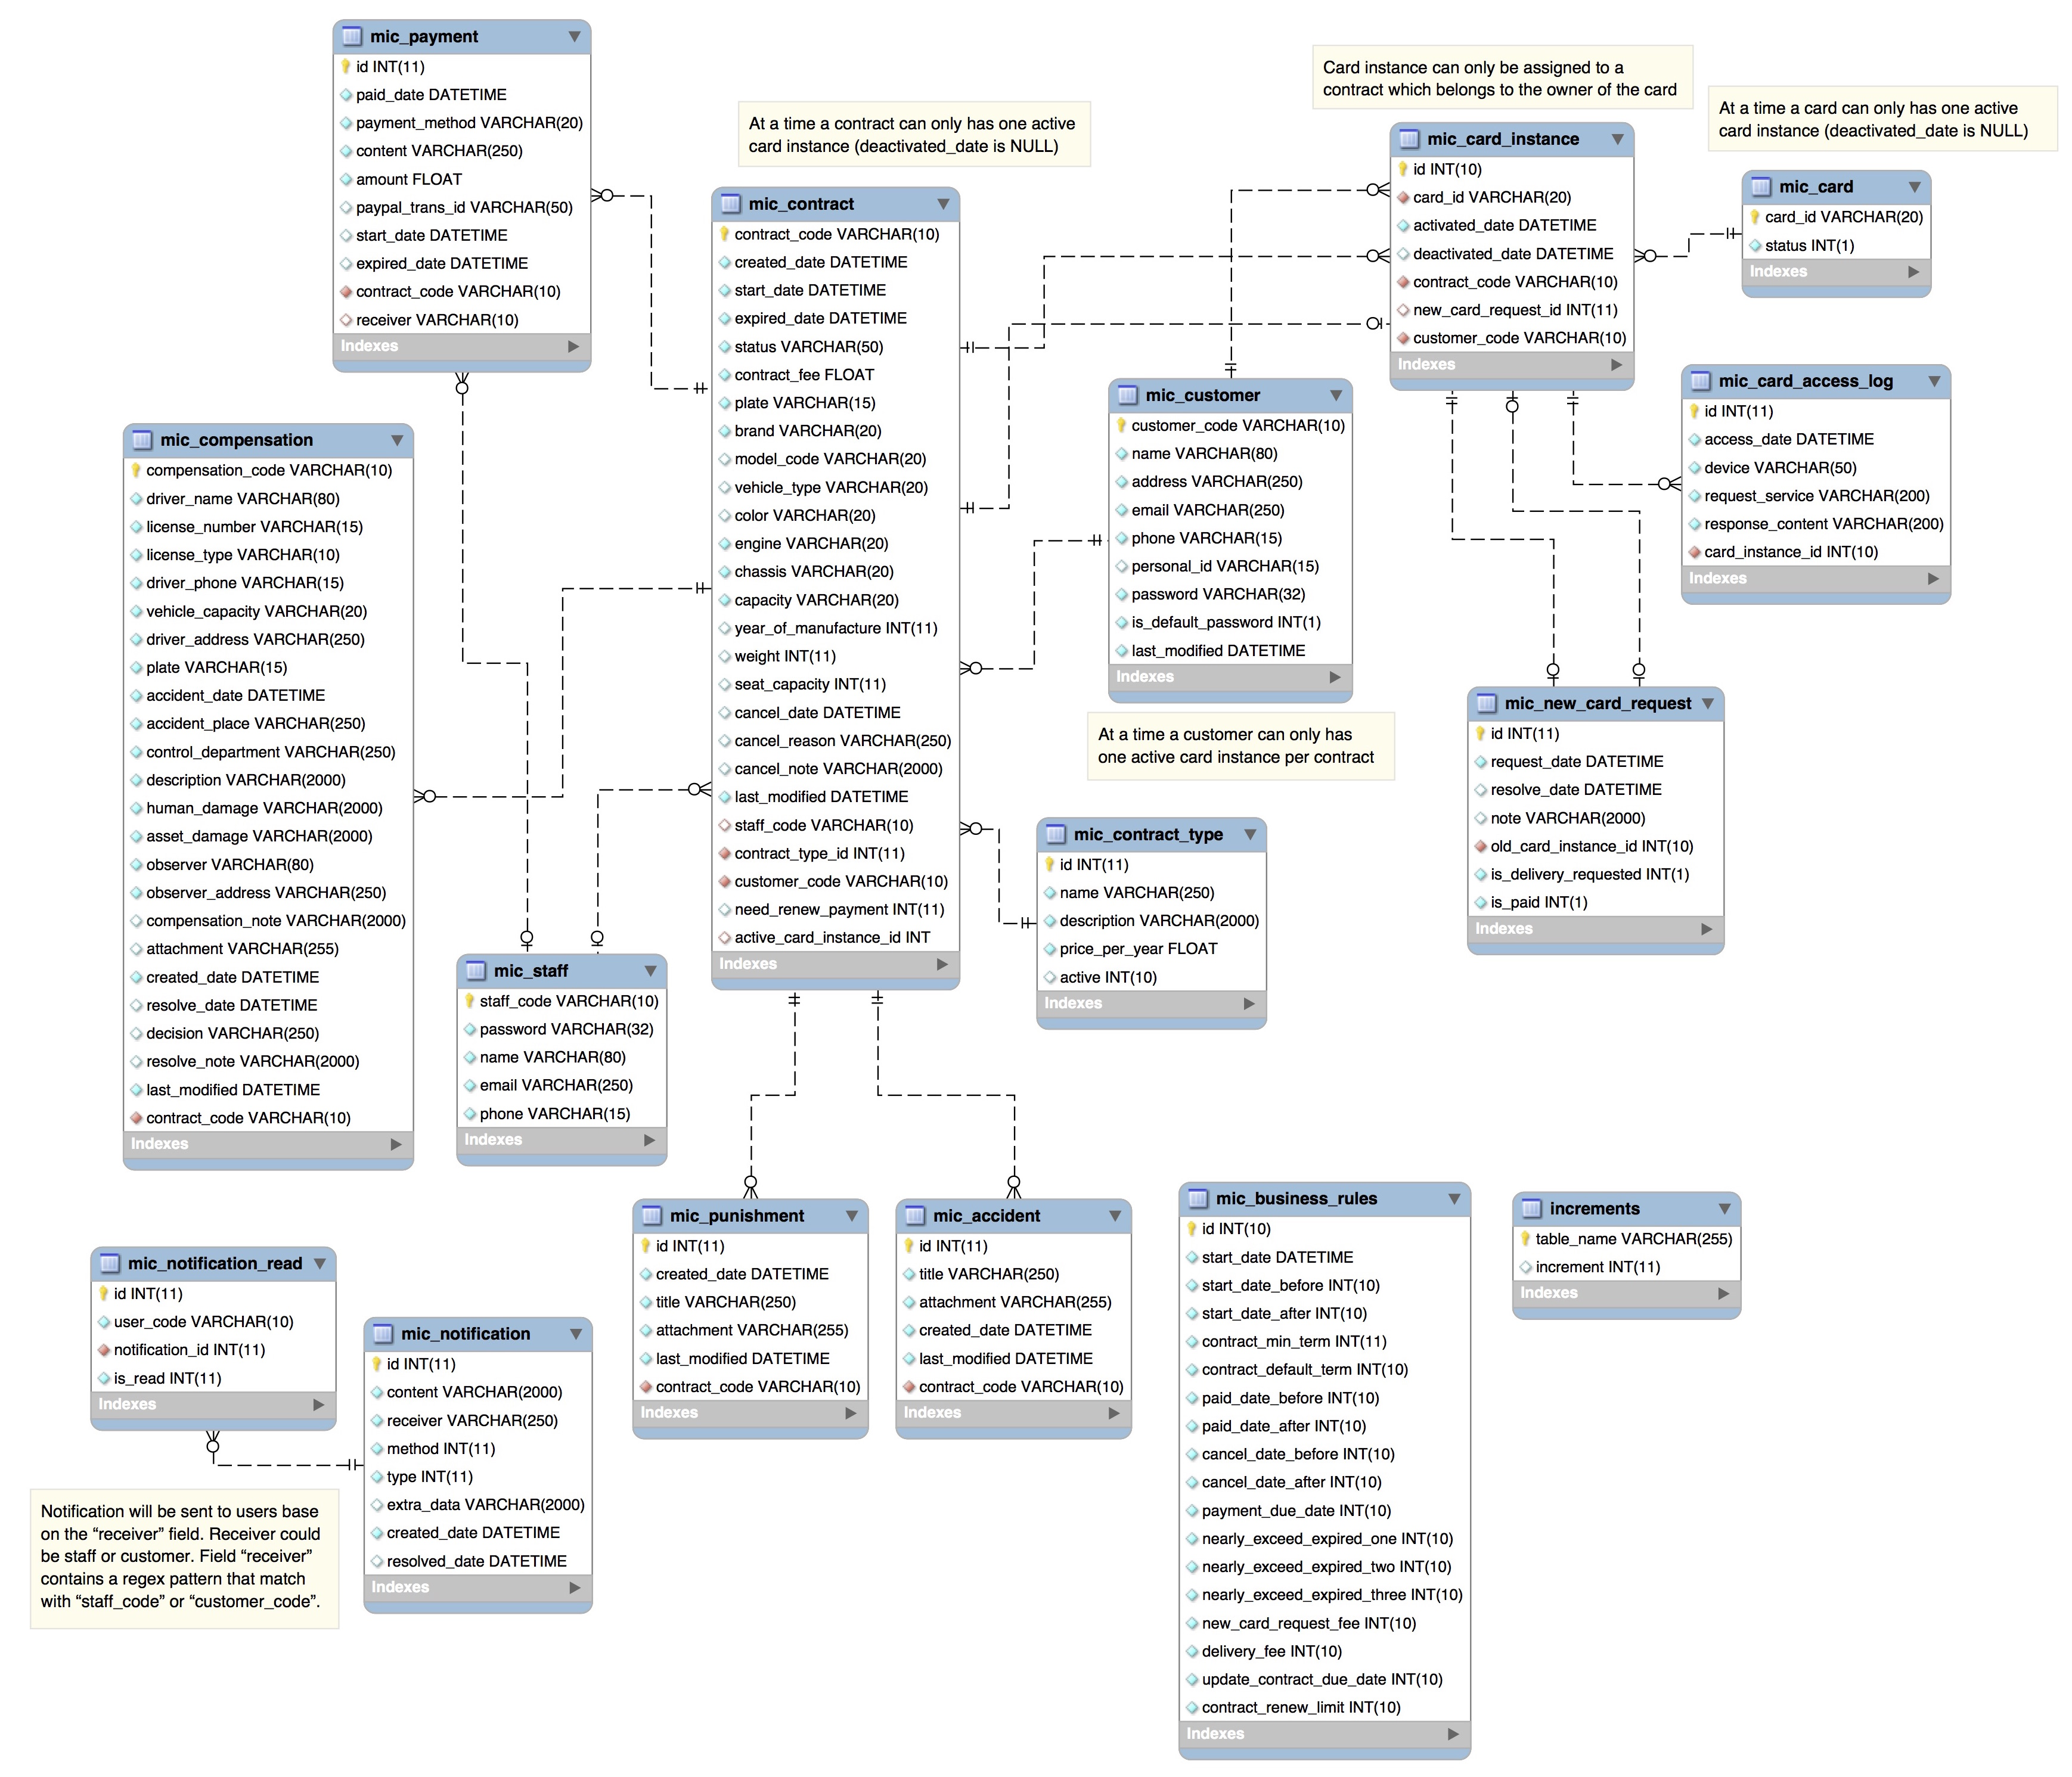

Figure 1 Physical diagram

### Data Dictionary

|  |  |  |
| --- | --- | --- |
| Data dictionary: describe content of all tables | | |
| Table Name | **Mapping with Conceptual diagram** | **Description** |
| increments | N/A | Not exist in conceptual diagram. Needed in physical diagram to generate codes with prefixes sequentially. |
| mic_business_rules | N/A | Not exist in conceptual diagram. Needed in physical diagram to describe all configuration based on company’s business rules. |
| mic_contract_type | ContractType | Describe all contract type in the system. |
| mic_contract | Contract | Describe all contract detail information in the system. |
| mic_accident | Accident | Describe all accident information belongs to contract in the system. |
| mic_compensation | Compensation | Describe all compensation detailed information belongs to contract in the system. |
| mic_punishment | Punishment | Describe all punishment information belongs to contract in the system. |
| mic_card | Card | Describe all card, which has been issued in the system. |
| mic_card_instance | CardInstance | Describe all card instance. |
| mic_card_access_log | N/A | Not exist in conceptual diagram. Needed in physical diagram to describe all history access to card. |
| mic_new_card_request | NewCardRequest | Describe all new card request in the system. |
| mic_customer | Customer | Describe all customer profile available in the system. |
| mic_notification | N/A | Not exist in conceptual diagram. Needed in physical diagram to describe all notification detail in the system. |
| mic_notification_read | N/A | Not exist in conceptual diagram. Needed in physical diagram to support manage all notification in the system. |
| mic_payment | Payment | Describe all payment information in the system. |
| mic_staff | Staff | Describe all staff profile available in the system. |

Table 1 Data table dictionary

|  |  |  |  |  |
| --- | --- | --- | --- | --- |
| Table Name | Attributes | Description | Domain | Null |
| increments | table_name {PK} | Unique identifier of increments | varchar(255) | No |
| increment |  |  | Yes |
| mic_business_rules | id {PK} | Unique identifier of business rules | int(10) | No |
| start_date_before | Duration contract start before current date | int(10) | No |
| start_date_after | Duration contract start after current date | int(10) | No |
| contract_min_term | Minimum contract term | int(11) | No |
| contract_default_term | Default contract term | int(10) | No |
| paid_date_before | Duration pay for contract before current date | int(10) | No |
| paid_date_after | Duration pay for contract after current date | int(10) | No |
| cancel_date_before | Duration cancel contract before current date | int(10) | No |
| cancel_date_after | Duration cancel contract after current date | int(10) | No |
| payment_due_date | Duration pay for contract from create date | int(10) | No |
| nearly_exceed_expired_one | Duration first time notify contract is going to expired | int(10) | No |
| nearly_exceed_expired_two | Duration second time notify contract is going to expired | int(10) | No |
| nearly_exceed_expired_three | Duration third time notify contract is going to expired | int(10) | No |
| new_card_request_fee | The amount has to paid for new card | int(10) | No |
| delivery_fee | The amount has to paid for delivery new card | int(10) | No |
| mic_contract_type | id {PK} | Unique identifier of contract type, auto increment. | int(11) | No |
| name | Contract type name. | varchar(250) | No |
| description | Contract type description. | varchar(2000) | No |
| price_per_year | Contract type price per year. | float | No |
| mic_contract | contract_code {PK} | Unique identifier of contract. | varchar(10) | No |
| created_date | Contract created date | datetime | No |
| start_date | Contract start date | datetime | No |
| expired_date | Contract expired date | datetime | No |
| status | Contract status | varchar(50) | No |
| contract_fee | Contract fee | float | No |
| plate | Vehicle plate | varchar(15) | No |
| brand | Vehicle brand | varchar(20) | No |
| model_code | Vehicle model code | varchar(20) | Yes |
| vehicle_type | Vehicle type | varchar(20) | Yes |
| color | Vehicle color | varchar(20) | Yes |
| engine | Vehicle engine number | varchar(20) | No |
| chassis | Vehicle chassis nuber | varchar(20) | No |
| capacity | Vehicle capacity | varchar(20) | No |
| year_of_manufacture | Vehicle year of manufacture | int(11) | Yes |
| weight | Vehicle empty weight | int(11) | Yes |
| seat_capacity | Vehicle seat capacity | int(11) | Yes |
| cancel_date | Contract cancel date | datetime | Yes |
| cancel_reason | Contract cancel reason | varchar(250) | Yes |
| cancel_note | Contract cancel note | varchar(2000) | Yes |
| last_modified | Contract last modified | datetime | No |
| staff_code | Code of the staff who created this contract | varchar(10) |  |
| contract_type_id | Contract type id | int(11) | No |
| customer_code | Code of the customer who own this contract | varchar(10) | No |
| active_card_instance_id | Active card instance of the contract | int(11) | Yes |
| mic_accident | id {PK} | Unique identifier of accident, auto increment. | int(11) | No |
| title | Accident title | varchar(250) | No |
| attachment | Accident attachment | varchar(255) | No |
| created_date | Accident created date | datetime | No |
| last_modified | Accident last modified | datetime | No |
| contract_code | Code of the contract has this accident | varchar(10) | No |
| mic_compensation | compensation_code {PK} | Unique identifier of compensation | varchar(10)PK | No |
| driver_name | Compensation driver name | varchar(80) | No |
| license_number | Compensation driver license number | varchar(15) | No |
| license_type | Compensation driver license type | varchar(10) | No |
| driver_phone | Compensation driver phone | varchar(15) | No |
| vehicle_capacity | Compensation driver vehicle capacity | varchar(20) | No |
| driver_address | Compensation driver address | varchar(250) | No |
| plate | Compensation driver vehicle plate | varchar(15) | No |
| accident_date | Compensation accident date | datetime | No |
| accident_place | Compensation accident place | varchar(250) | No |
| control_department | Department which control this accident | varchar(250) | No |
| description | Compensation description | varchar(2000) | No |
| human_damage | Accident human damage | varchar(2000) | No |
| asset_damage | Accident asset damage | varchar(2000) | No |
| observer | Observer name | varchar(80) | No |
| observer_address | Observer address | varchar(250) | No |
| compensation_note | Compensation note | varchar(2000) | Yes |
| attachment | Compensation attachment | varchar(255) | Yes |
| created_date | Compensation created date | datetime | No |
| resolve_date | Compensation resolve date | datetime | Yes |
| decision | Compensation decision | varchar(250) | Yes |
| resolve_note | Compensation resolve note | varchar(2000) | Yes |
| last_modified | Compensation last modified time | datetime | No |
| contract_code | Code of the contract has this compensation | varchar(10) | No |
| mic_punishment | id {PK} | Unique identifier of punishment, auto increment. | int(11) | No |
| title | Punishment title | varchar(250) | No |
| attachment | Punishment attachment | varchar(255) | No |
| created_date | Punishment created date | datetime | No |
| last_modified | Punishment last modified | datetime | No |
| contract_code | Code of the contract has this punishment | varchar(10) | No |
| mic_card | card_id | Unique identifier of card | varchar(20) | No |
| status | Status of the card | int(1) | No |
| mic_card_instance | Id {PK} | Unique identifier of card instance. | int(11) | No |
| card_id | Card ID of the instance | varchar(20) | No |
| activated_date | Card activated date | datetime | No |
| deactivated_date | Card deactivated date | datetime | Yes |
| contract_code | Code of contract has this card | varchar(10) | No |
| new_card_request_id | New card request id | int(11) | Yes |
| customer_code | Customer code, owner of the card | varchar(10) | No |
| mic_card_access_log | id {PK} | Unique identifier of card access log, auto increment. | int(11) | No |
| access_date | Access card date | datetime | No |
| device | Access card device | varchar(50) | No |
| request_service | Service requested | varchar(200) | No |
| response_content | Content responsed | varchar(200) | No |
| card_id | Card ID | varchar(20) | No |
| mic_new_card_request | id {PK} | Unique identifier of new card request, auto increment. | int(11) | No |
| request_date | Send request date | datetime | No |
| resolve_date | Resolve request date | datetime | Yes |
| note | Resolve request note | varchar(2000) | Yes |
| old_card_id | ID of old card | varchar(20) | No |
| mic_customer | customer_code{PK} | Unique identifier of customer | varchar(10) | No |
| name | Customer name | varchar(80) | No |
| address | Customer address | varchar(250) | No |
| email | Customer email | varchar(250) | No |
| phone | Customer phone | varchar(15) | No |
| personal_id | Customer personal ID | varchar(15) | Yes |
| password | Customer password | varchar(32) | No |
| is_default_password | Value to check customer password is default or not. | int(1) | No |
| last_modified | Customer last modified time | datetime | No |
| mic_notification | id {PK} | Unique identifier of notification, auto increment. | int(11) | No |
| content | Notification content | varchar(2000) | No |
| receiver | Notification receiver | varchar(250) | No |
| method | Notification method | int(11) | No |
| type | Notification type | int(11) | No |
| extra_data | Notification extra data | varchar(2000) | Yes |
| created_date | Notification created date | datetime | No |
| resolved_date | Notification resolved date | datetime | Yes |
|
| mic_notification_read | id {PK} | Unique identifier of notification read, auto increment. | int(11) | No |
| user_code | Code of user read this notification | varchar(10) | No |
| notification_id | Notification ID | int(11) | No |
| is_read | Value to check notification is read or not yet. | int(11) | No |
| mic_payment | id {PK} | Unique identifier of payment, auto increment. | int(11) | No |
| paid_date | The date the payment is paid | datetime | No |
| payment_method | Payment method | varchar(20) | No |
| content | Payment content | varchar(250) | No |
| amount | Payment amount | float | No |
| paypal_trans_id | PayPal transaction ID | varchar(50) | Yes |
| start_date | Contract start date while payment content is renew | datetime | Yes |
| expired_date | Contract expired date while payment content is renew | datetime | Yes |
| contract_code | Code of contract has this payment | varchar(10) | No |
| receiver | Payment receiver | varchar(10) | Yes |
| mic_staff | staff_code {PK} | Unique identifier of staff | varchar(10) | No |
| password | Staff password | varchar(32) | No |
| name | Staff name | varchar(80) | No |
| email | Staff email | varchar(250) | No |
| phone | Staff phone | varchar(15) | No |

Table 2 Data attribute dictionary

## Performance Measures

### Web application page load speed

#### Definition

This section tests the general page load speed from all the page of the web application.

#### Test environment

**Server:**

* **Operating system:** Ubuntu 14.04 Server 32 bit
* **RAM:** 512 MB
* **Storage:** 40 GB
* **Processor:** 2.6 GHz Intel Core i5
* **Network:** 1 Mbps

#### Test cases

Using browser from client side and go to each page of the web application. Record the page load time using Chrome Dev Tools at client side.

**Test pages:**

|  |  |
| --- | --- |
| Public | home |
| register |
| checkout |
| login |
| Staff | dashboard |
| contract:   * list contract * detail contract * create contract |
| compensation:   * list all compensation * list compensation by contract * detail compensation * create compensation * edit compensation |
| punishment   * list punishment by contract * create punishment * edit punishment |
| accident   * list accident by contract * create accident * edit accident |
| card   * list card * detail card * list new card request |
| customer   * list customer * customer detail * create customer * edit customer information |
| Customer | dashboard |
| contract   * list contract * detail contract * create new contract |
| compensation:   * list compensation by contract * detail compensation * create compensation |
| punishment   * list punishment by contract * create punishment |
| accident   * list accident by contract * create accident |
| card   * list card * detail card * list new card request |
| profile information |

#### Test result

The test is run 10 times, each time we go through all the pages listed above and log down the average page load time.

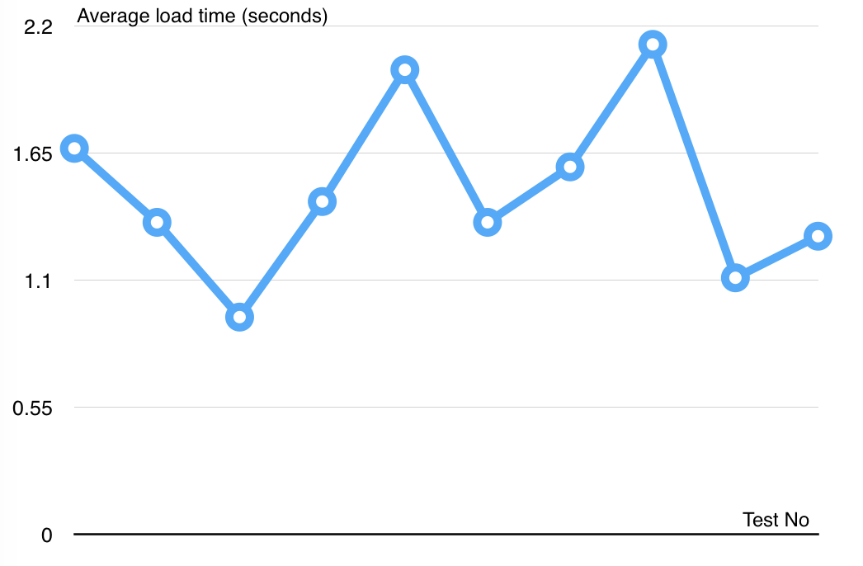

Figure 2 Web application page load speed test result

|  |  |  |
| --- | --- | --- |
| Test No. | Average page load time (second) | Execute date |
| 1 | 1.67 | 6 July 2015 |
| 2 | 1.35 | 6 July 2015 |
| 3 | 0.94 | 6 July 2015 |
| 4 | 1.44 | 6 July 2015 |
| 5 | 2.01 | 6 July 2015 |
| 6 | 1.35 | 6 July 2015 |
| 7 | 1.59 | 6 July 2015 |
| 8 | 2.12 | 6 July 2015 |
| 9 | 1.11 | 6 July 2015 |
| 10 | 1.29 | 6 July 2015 |
|  | **Average: 1.49 (seconds)** |  |

Table 3 Web application page load speed test result

### Mobile application API load speed

#### Definition

This section tests the load speed of mobile apps when connection to server through API.

#### Test environment

**Server:**

* **Operating system:** Ubuntu 14.04 Server 32 bit
* **RAM:** 512 MB
* **Storage:** 40 GB
* **Processor:** 2.6 GHz Intel Core i5
* **Network:** 1 Mbps

**Client:**

|  |  |  |
| --- | --- | --- |
| Hardware Requirements | Minimum | Recommended |
| Internet Connection | 512Kbps | Wi-Fi Connection 12MB |
| Operating System | Android 4.0 | Android 4.0 |
| Hardware | NFC supported | NFC supported |
| Memory | 128MB of RAM | 1GB of RAM or more |

#### Test cases

Using mobile application to send the entire API request to web server.

List of APIs:

|  |  |  |
| --- | --- | --- |
| No. | API | Description |
| 1 | getCheckConnection | Check server status |
| 2 | getContracts | Get contract information |
| 3 | getUpdateCardID | Update Card ID for contract |
| 4 | getCheckCard | Check card validation |
| 5 | getUpdatePunishment | Update punishment information for contract |

#### Test result

The test is run 10 times, each time we run all the test cases listed above and log down the average API response time.

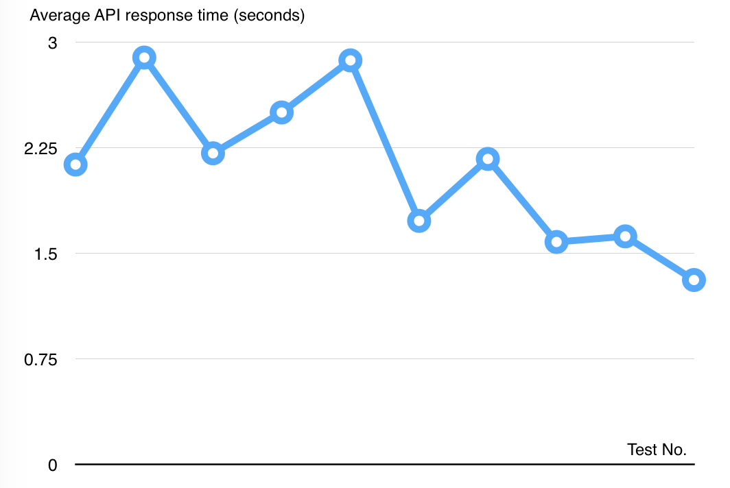

Figure 3 Mobile application API load speed test result

|  |  |  |
| --- | --- | --- |
| Test No. | Average page load time (second) | Execute date |
| 1 | 2.13 | 6 July 2015 |
| 2 | 2.89 | 6 July 2015 |
| 3 | 2.21 | 6 July 2015 |
| 4 | 2.5 | 6 July 2015 |
| 5 | 2.87 | 6 July 2015 |
| 6 | 1.73 | 6 July 2015 |
| 7 | 2.17 | 6 July 2015 |
| 8 | 1.58 | 6 July 2015 |
| 9 | 1.62 | 6 July 2015 |
| 10 | 1.31 | 6 July 2015 |
|  | **Average: 2.10 (seconds)** |  |

Table 4 Mobile application API load speed test result

## Test Plan

The overall purpose of testing is to ensure MIC system meets its entire technical, functional and business requirement. The purpose of this document is to describe the overall test plan and strategy for testing the MIC system. The approach described in this document provides the framework for all testing related to this application. Individual test cases will be written for each version of the application that is released. This document will also be updated as required for each release.

### Features to be tested

* Staff: view contract information, view compensation information, resolve new card request, resolve compensation request, create new contract, renew contract, cancel contract.
* Customer: view contract information, view compensation information, renew contract, cancel contract, request compensation, new card request, change password.
* Guest: Create new contract request
* System: notify schedule
* Mobile application: verify card, add punishment, print card

### Features not to be tested

* Admin: add staff, remove staff
* Login, logout, change profile
* View information: card, punishment, accident, customer, staff, payment.

## System Testing Test Case

#### <Staff> View Contracts

|  |  |  |  |  |  |  |
| --- | --- | --- | --- | --- | --- | --- |
| ID | Test case description | Test case procedure | Expected output | Inter-test case dependence | Result | Test date |
| WC1 | View contract detail | 1. Create a contract with code HD0001  2. Click contract code in the grid to view its detail | Display contract detailed information page | CC1 - Create Contract | Pass | 7/13/15 |
| WC2 | Search contract with customer name | 1. Create 3 customer with names "Dang Van Ngu", "Duong Tu Ky" and "Nguyen Dinh Bao" alternatively  2. Create 2 contract HD0001 and HD0002 belongs to "Dang Van Ngu" and "Nguyen Dinh Bao" in turn  3. Input "Nguyen Dinh Bao" to search box  4. Click "Tìm kiếm" button | Display contract HD0002 in the grid view | Create Customer  CC1 - Create Contract | Pass | 7/13/15 |
| WC3 | Search contract with no keyword | 1. Create 3 customer with names "Dang Van Ngu", "Duong Tu Ky" and "Nguyen Dinh Bao" alternatively  2. Create 2 contract HD0001 and HD0002 belongs to "Dang Van Ngu" and "Nguyen Dinh Bao" in turn  3. Click "Tìm kiếm" button | A message notify there are no value for this search | Create Customer  CC1 - Create Contract | Pass | 7/13/15 |

#### <Staff> Create Contract

|  |  |  |  |  |  |  |
| --- | --- | --- | --- | --- | --- | --- |
| ID | Test case description | Test case procedure | Expected output | Inter-test case dependence | Result | Test date |
| CC1 | Create contract success | 1. Create customer "Nguyen Van A" has customer code is KH0001  2. Click create new contract, input form is displayed  3. Input all default value according to "Default_value_for_forms.xlsx" file  4. Set customer code is KH0001, contract start date to 12 July 2015  5. Click "Tạo hợp đồng" button | A contract with status is "No card" created successfully | Create Customer | Pass | 7/13/15 |
| CC2 | Create contract success but not start yet | 1. Create customer "Nguyen Van A" has customer code is KH0001  2. Click create new contract, input form is displayed  3. Input all default value according to "Default_value_for_forms.xlsx" file  4. Set customer code is KH0001, contract start date to 21 July 2015  5. Click "Tạo hợp đồng" button | A contract with status is "Pending" created successfully | Create Customer | Pass | 7/13/15 |
| CC3 | Create contract fail because of existed vehicle plate number | 1. Create customer "Nguyen Van A" has customer code is KH0001, customer "Duong Thien Hoa" has customer code is KH0002  2. Create new contract with start date is 12 July 2015, contract status is Ready, vehicle plate number is 59Y9-38482  3. Click create new contract, input form is displayed  4. Input all default value according to "Default_value_for_forms.xlsx" file  5. Set vehicle plate number is 59Y9-38482  6. Click "Tạo hợp đồng" button | A message notify this vehicle plate number is existed in the system | Create Customer  CC1 - Create Contract | Pass | 7/13/15 |
| CC4 | Create contract fail because of there are no customer | 1. Create customer "Nguyen Van A" has customer code is KH0001  2. Click create new contract, input form is displayed  3. Input all default value according to "Default_value_for_forms.xlsx" file, customer code is KH0002  4. Set contract start date to 12 July 2015  5. Click "Tạo hợp đồng" button | A message notify this customer is not exist in the system | Create Customer | Pass | 7/13/15 |

#### <Staff> Renew Contract

|  |  |  |  |  |  |  |
| --- | --- | --- | --- | --- | --- | --- |
| ID | Test case description | Test case procedure | Expected output | Inter-test case dependence | Result | Test date |
| RC1 | Renew contract success | 1. Create new contract has start date is 10 July 2015, expired date is 1 September 2015. Contract status is "No card"  2. Click view this contract detail  3. Click "Gia hạn" button, renew contract form displayed  4. Fill out the form:  - Gia hạn đến: 01/09/2016  - Ngày nộp phí:  13/07/2015  5. Click "Gia hạn hợp đồng" button | Renew contract successfully, contract status is "No card"  A new payment is created with start date is 01/09/2015, expired date is 01/09/2016 | CC1 - Create Contract  WC1 - View Contracts | Pass | 7/13/15 |
| RC2 | Renew contract success with request for new card and delivery it | 1. Create new contract has start date is 9 July 2015, expired date is 13 August 2015. Contract status is "No card"  2. Print a card with code "12-34-56-78-91" for this contract. Contract new status is "Ready"  3. Click view this contract detail  4. Click "Gia hạn" button, renew contract form displayed button  5. Fill out the form:  - Gia hạn đến: 13/08/2016  - Ngày nộp phí:  13/07/2015  6. Check "Cấp thẻ mới", "Vận chuyển thẻ" boxes  7. Click "Gia hạn hợp đồng" button | Renew contract successfully, its status is "No card".  A new payment is created with start date is 13/08/2015, expired date is 13/08/2016  The card with code "12-34-56-78-91" is deactivated | CC1 - Create Contract  Print Card  WC1 - View Contracts | Pass | 7/13/15 |
| RC3 | Renew contract success | 1. Create new contract has start date is 6 July 2015, expired date is 12 July 2015. Contract status is "Expired"  2. Click view this contract detail  3. Click "Gia hạn" button, renew contract form displayed  4. Fill out the form:  - Gia hạn đến: 13/08/2016  - Ngày nộp phí:  13/07/2015  5. Click submit button | Renew contract successfully, contract status is "No card"  A new payment is created with start date is 13/07/2015, expired date is 13/07/2016 | CC1 - Create Contract  WC1 - View Contracts | Pass | 7/13/15 |
| RC4 | Renew contract fail because of contract term is out of bound | 1. Create new contract has start date is 6 July 2015, expired date is 12 August 2015. Contract status is "No card"  2. Click view this contract detail  3. Click "Gia hạn" button, renew contract form displayed  4. Fill out the form:  - Gia hạn đến: 13/12/2016  - Ngày nộp phí:  13/07/2015  5. Click "Gia hạn hợp đồng" button | A message notify contract term can not exceed the limit | CC1 - Create Contract  WC1 - View Contracts | Pass | 7/13/15 |
| RC5 | Renew contract success with request for new card fail because this contract have no card | 1. Create new contract has start date is 6 July 2015, expired date is 12 July 2015. Contract status is "Expired"  2. Click view this contract detail  3. Click "Gia hạn" button, renew contract form displayed  4. Fill out the form:  - Gia hạn đến: 13/08/2016  - Ngày nộp phí:  13/07/2015  5. Check "Cấp thẻ mới" box  6. Click "Gia hạn hợp đồng" button | A message notify this contract have no card | CC1 - Create Contract | Pass | 7/13/15 |

#### <Staff> Cancel Contract

|  |  |  |  |  |  |  |
| --- | --- | --- | --- | --- | --- | --- |
| ID | Test case description | Test case procedure | Expected output | Inter-test case dependence | Result | Test date |
| CC1 | Cancel contract having "Ready" status | 1. Create new contract has start date is 11 July 2015, expired date is 11 July 2016. Contract status is "No card"  2. Print a card with code "12-34-56-78-AZ" for this contract. Contract new status is "Ready"  3. Click view this contract detail  4. Click "Hủy hợp đồng" button, cancel contract form displayed  5. Fill out the form:  - Ngày hủy hợp đồng: 13/07/2015  - Lý do hủy hợp đồng: Mất xe  6. Click "Đồng ý hủy" button | Cancel contract successfully, its status is "Cancelled".  The card with code "12-34-56-78-AZ" is deactivated | CC1 - Create Contract  PC1 - Print Card  WC1 - View Contracts | Pass | 7/13/15 |
| CC2 | Cancel contract having "Request cancel" status | 1. Create new contract has start date is 11 July 2015, expired date is 11 July 2016. Contract status is "Request cancel"  2. Click view this contract detail  3. Click handle cancel contract request button, cancel contract form displayed  4. Quyết định của công ty: Hủy hợp đồng này  5. Click "Xác nhận" button | Cancel contract successfully, its status is "Cancelled". | CC1 - Create Contract  WC1 - View Contracts | Pass | 7/13/15 |
| CC3 | Cancel contract fail because of cancel reason is empty | 1. Create new contract has start date is 11 July 2015, expired date is 11 July 2016. Contract status is "No card"  2. Click view this contract detail  3. Click "Hủy hợp đồng" button, cancel contract form displayed  4. Click "Đồng ý hủy" button | A message notify cancel reason is can not empty, request Staff to fill it out | CC1 - Create Contract  WC1 - View Contracts | Pass | 7/13/15 |

#### <Staff> View Compensation List

|  |  |  |  |  |  |  |
| --- | --- | --- | --- | --- | --- | --- |
| ID | Test case description | Test case procedure | Expected output | Inter-test case dependence | Result | Test date |
| WCL1 | View compensation list | 1. Create new contract with code is "HD0001"  2. Create new compensation for "HD0001" contract  3. Click view list of compensation | A grid view display list of compensation | CC1 - Create Contract  Create Compensation | Pass | 7/11/15 |
| WCL2 | Search compensation with contract code | 1. Create 2 new contract with code is "HD0001", "HD0002"  2. Create 4 new compensation, 2 for each contract  3. Input "HD0001" to search box  4. Click "Tìm kiếm" button | A grid view display 2 compensation belongs to the contract has code "HD0001" | CC1 - Create Contract  Create Compensation | Pass | 7/12/15 |
| WCL3 | Search contract with no keyword | 1. Create 2 new contract with code is "HD0001", "HD0002"  2. Create 4 new compensation, 2 for each contract  3. Click "Tìm kiếm" button | A message notify there are no value for this search | CC1 - Create Contract  Create Compensation | Pass | 7/13/15 |

#### <Staff> Compensation Detail

|  |  |  |  |  |  |  |
| --- | --- | --- | --- | --- | --- | --- |
| ID | Test case description | Test case procedure | Expected output | Inter-test case dependence | Result | Test date |
| CD1 | View an unsolved compensation detail | 1. Create new contract  2. Create new compensation for this contract  3. Click compensation code in list of compensation | Display compensation detail page with an alert about resolve this compensation | CC1 - Create Contract  Create Compensation | Pass | 7/13/15 |
| CD2 | View an solved compensation detail | 1. Create new contract  2. Create new compensation for this contract  3. Resolve this compensation  4. Click compensation code to view its detail | Display compensation detail page with solved compensation information | CC1 - Create Contract  Create Compensation  RC1 - Resolve Compensation | Pass | 7/13/15 |

#### <Staff> Resolve Compensation

|  |  |  |  |  |  |  |
| --- | --- | --- | --- | --- | --- | --- |
| ID | Test case description | Test case procedure | Expected output | Inter-test case dependence | Result | Test date |
| RC1 | Resolve compensation success | 1. Create new contract  2. Create new compensation for this contract  3. Click compensation code in list of compensation  4. Click "Giải quyết yêu cầu" button, solve form is displayed  5. Fill out the form:  - Ngày giải quyết yêu cầu: 13/07/2015  - Quyết định của công ty: "Từ chối bồi thường"  6. Click "Quyết định" button | Display compensation detail page with solved compensation information | CC1- Create Contract  Create Compensation | Pass | 7/13/15 |

#### <Staff> View new card requests

|  |  |  |  |  |  |  |
| --- | --- | --- | --- | --- | --- | --- |
| ID | Test Case Description | Test case procedure | Expected output | Inter-test case dependence | Result | Test Date |
| VNCR1 | Test list new card request in ascending order of request date. | 1. Create 5 new card request with 5 different request date.  2. Click "Yêu cầu thẻ mới" bar. | Display the list new card requests in ascending order of request date. | SNCR1 | Pass | 7/13/15 |
| VNCR2 | Test unresolved request will be on top. | 1. Crete 5 new card request with the same request date. But 2 of them is resolved.  2. Click "Yêu cầu thẻ mới" bar. | Display 3 unresolved new card requests on top and 2 resolved new card request on bottom. | SNCR1 | Pass | 7/13/15 |

#### <Staff> Resolve new card request

|  |  |  |  |  |  |  |
| --- | --- | --- | --- | --- | --- | --- |
| ID | Test Case Description | Test case procedure | Expected output | Inter-test case dependence | Result | Test Date |
| RNCR1 | Test resolve new card request, print a new card | 1. Contract HD0001 is Ready and having an actived card.  2. Create new card request for contract HD001 like test case SNCR1.  3. Print card for Ready contract "HD0001" like test case PC2. | Printer app show message "Write success", contract card change to new card ID, old card is deactivated | SNCR1,PC2. | Pass | 7/13/15 |

#### <Customer> Create New Contract

|  |  |  |  |  |  |  |
| --- | --- | --- | --- | --- | --- | --- |
| ID | Test Case Description | Test case procedure | Expected output | Inter-test case dependence | Result | Test Date |
| CNC1 | Create new contract success | 1. Click "Hợp đồng mới" button.  2. Input all default value according to Default form value.xlsx file" (Create new contract form)  3. Click "Thêm hợp đồng"  4. Click "Xác nhận"  5. Click "Thanh toán ngay bây giờ"  6. Login to paypla an pay fee | Customer can see their new contract with status "No card" and some information about compensation, punishment, accident and card | Default form value.xlsx file | Pass | 7/13/15 |
| CNC2 | Create new contract fail | 1. Click "Hợp đồng mới" button.  2. Click "Thêm hợp đồng" | Sytem show message error and required input value | Default form value.xlsx file | Pass | 7/13/15 |
| CNC3 | Create new contract success | 1. Click "Hợp đồng mới" button.  2. Input all default value according to Default form value.xlsx file" (Create new contract form)  3. Click "Thêm hợp đồng"  4. Click "Xác nhận"  5. Click "Thanh toán ngay bây giờ"  6. Click "Trực tiếp" | System shows map with detail address of company where customer can pay direct for their contract.  Customer can see their new contract with status "Pending" and some information about compensation, punishment, accident and card | Default form value.xlsx file | Pass | 7/13/15 |
| CNC4 | Create new contract fail | 1. Click "Hợp đồng mới" button.  2. Input all default value according to Default form value.xlsx file" (Create new contract form)  3. Thời điểm có hiệu lực input "07/04/2015"  3. Click "Thêm hợp đồng" | Sytem show message error "Thời điểm có hiệu lực phải sau ngày hiện tại" | Default form value.xlsx file | Pass | 7/13/15 |

#### <Customer> Renew Contract

|  |  |  |  |  |  |  |
| --- | --- | --- | --- | --- | --- | --- |
| ID | Test Case Description | Test case procedure | Expected output | Inter-test case dependence | Result | Test Date |
| RC1 | Renew contract success | 1. Create new contract with contract code "HD0001"  2. Prepare a contract with startdate: 7/25/2014 and expireddate: 7/25/2015 and status is "Ready"  3. Click "Gia hạn" button  4. Click "Gia hạn hợp đồng"  5. Choose "Paypal" and login paypal to pay fee  6. Click "Trở về trang chi tiết hợp đồng" | System show page with message "Gia hạn thành công" and expired is updated "7/26/2016" | Create new contract | Pass | 7/13/15 |
| RC2 | Renew contract success | 1. Create new contract with contract code "HD0001"  2. Prepare a contract with startdate: 7/11/2014 and expireddate: 7/11/2015 and status is "Expired"  3. Click "Gia hạn" button  4. Click "Gia hạn hợp đồng"  5. Choose "Paypal" and login paypal to pay fee  6. Click "Trở về trang chi tiết hợp đồng" | System show page with message "Gia hạn thành công" and expired is updated "7/13/2016" and status change to "Ready" | Create new contract | Pass | 7/13/15 |
| RC3 | Renew contract fail | 1. Login with role customer  1. Create new contract with contract code "HD0001" with  2. Prepare a contract with status Expired  3. Open new browser and login with role Staff and goes into contract-detail at contract code "HD0001"  4. Click "Gia hạn hợp đồng" at browser staff  5. Do action like RC2  6 Click "Gia hạn hợp đồng" at browser customer | System will show error message "Thông tin hợp đồng đã bị sửa đổi trước đó bởi một người khác, vui lòng thực hiện lại thao tác" | Create new contract | Pass | 7/13/15 |

#### <Customer> Cancel Contract

|  |  |  |  |  |  |  |
| --- | --- | --- | --- | --- | --- | --- |
| ID | Test Case Description | Test case procedure | Expected output | Inter-test case dependence | Result | Test Date |
| CC1 | Cancel contract success | 1. Create new contract with contract code "HD0001"  2. Prepare a contract with status "Ready" check resson cancel  3. Click "Hủy hợp đồng" button  4. Click " Xe cơ giới bị mất được cơ quan công an xác nhận"  5. Click "Xác nhận" button | System will reload page and change status into "Request cancel" and show detail of request cancel, show "Hủy yêu cầu button" | Create new contract | Pass | 7/13/15 |
| CC2 | Cancel contract fail | 1. Login with role customer  1. Create new contract with contract code "HD0001" with  2. Prepare a contract with status Ready  3. Open new browser and login with role Staff and goes into contract-detail at contract code "HD0001"  4. Click "Hủy hợp đồng" at browser staff  5. Do action like CC1  6. Click "Hủy hợp đồng" at browser customer | System will show error message "Thông tin hợp đồng đã bị sửa đổi trước đó bởi một người khác, vui lòng thực hiện lại thao tác" | Create new contract | Pass | 7/13/15 |
| CC3 | Cancel contract contract fail | 1. Create new contract with contract code "HD0001"  2. Prepare a contract with status "Ready"  3. Click "Hủy hợp đồng" button  4. Click "Xác nhận" button | System will show error message "Vui lòng chọn lí do hủy hợp đồng trước khi xác nhận. Cảm ơn!" | Create new contract | Pass | 7/13/15 |
| CC4 | Cancel contract contract fail | 1. Create new contract with contract code "HD0001"  2. Prepare a contract with status "Ready"  3. Click "Lý do khác" radio check  4. Click "Xác nhận" button | System will show error message "Vui lòng chọn lí do hủy hợp đồng trước khi xác nhận. Cảm ơn!" | Create new contract | Pass | 7/13/15 |
| CC5 | Cancel contract contract fail | 1. Create new contract with contract code "HD0001"  2. Prepare a contract with status "Ready"  3. Click "Lý do khác" radio check  4. Input blank value into texterea  4. Click "Xác nhận" button | System will show error message "Vui lòng chọn lí do hủy hợp đồng trước khi xác nhận. Cảm ơn!" | Create new contract | Pass | 7/13/15 |

#### <Customer> Send Compensation Request

|  |  |  |  |  |  |  |
| --- | --- | --- | --- | --- | --- | --- |
| ID | Test Case Description | Test case procedure | Expected output | Inter-test case dependence | Result | Test Date |
| SCR1 | Send compensation success | 1. Create contract with contract code "HD0001"  2. Click on "Hợp đồng" menu  3. Search Contract with code "HD0001"  4 Click link "HD0001"  5. Click tab "Lịch sữ bồi thường"  6. Click "Yêu cầu bồi thương"  7. Input all default value according to Default form value.xlsx file" (Create new compensation)  8. Click "Gởi yêu cầu"  9. Click "Trở về trang chi tiết hợp đồng" | System show compensation detaiil about request compensation they just send | Create new  contract  Default form value.xlsx file | Pass | 7/13/15 |
| SCR2 | Send compensation fail | 1. Create contract with contract code "HD0001"  2. Click on "Hợp đồng" menu  3. Search Contract with code "HD0001"  4 Click link "HD0001"  5. Click tab "Lịch sữ bồi thường"  6. Click "Yêu cầu bồi thương"  7. Input all default value according to Default form value.xlsx file" (Create new compensation)  8. Ngày xảy ra tai nạn input "09/13/2015"  8. Click "Gởi yêu cầu" | System show error message "Ngày xảy ra tai nạn phải trước ngày hiện tại" | Create new  contract  Default form value.xlsx file | Pass | 7/13/15 |
| SCR3 | Send compensation fail | 1. Create contract with contract code "HD0001"  2. Click on "Hợp đồng" menu  3. Search Contract with code "HD0001"  4 Click link "HD0001"  5. Click tab "Lịch sữ bồi thường"  6. Click "Yêu cầu bồi thương"  8. Click "Gởi yêu cầu" | System show error message "Vui lòng nhập giá trị" and required input into some field have "*" symbol | Create new  contract  Default form value.xlsx file | Pass | 7/13/15 |

#### <Customer> Send new card request

|  |  |  |  |  |  |  |
| --- | --- | --- | --- | --- | --- | --- |
| ID | Test Case Description | Test case procedure | Expected output | Inter-test case dependence | Result | Test Date |
| SNCR1 | Test send new card request with direct payment. | 1. Contract HD0001 having an actived card. No new card request before.  2. In "Yêu Cầu Thẻ Mới" page for contract HD0001, input fields:  - Mật khẩu: correct password  - Ghi chú: "Làm lại thẻ".  - Choose: "Thanh toán trực tiếp(tại công ty)"  - Uncheck "Hủy bỏ thẻ cũ"  3. Click "Xác nhận" button. | Show success message:"Yêu cầu thẻ mới thành công. Vui lòng đến trực tiếp để thanh toán". Create new card request record. |  | Pass | 7/13/15 |
| SNCR2 | Test send new card and deactivate old card request with direct payment. | 1. Contract HD0001 having an actived card. No new card request before.  2. In "Yêu Cầu Thẻ Mới" page for contract HD0001, input fields:  - Mật khẩu: correct password  - Ghi chú: "Làm lại thẻ".  - Choose: "Thanh toán trực tiếp(tại công ty)"  - Check "Hủy bỏ thẻ cũ"  3. Click "Xác nhận" button. | Show success message:"Yêu cầu thẻ mới thành công. Vui lòng đến trực tiếp để thanh toán". Create new card request record and the old card been deactivated. |  | Pass | 7/13/15 |
| SNCR3 | Test send new card request with PayPal payment. | 1. Contract HD0001 having an actived card. No new card request before.  2. In "Yêu Cầu Thẻ Mới" page for contract HD0001, input fields:  - Mật khẩu: correct password  - Ghi chú: "Làm lại thẻ".  - Choose: "Thanh toán qua PayPal"  - Uncheck "Hủy bỏ thẻ cũ"  - Check "Nhận thẻ tại công ty"  3. Click "Xác nhận" button.  4. User log in and pay with PayPal web page. | Show success message:"Thanh toán thành công".Create new card request record. |  | Pass | 7/13/15 |
| SNCR4 | Test send new card and deactivate old card request with PayPal payment. | 1. Contract HD0001 having an actived card. No new card request before.  2. In "Yêu Cầu Thẻ Mới" page for contract HD0001, input fields:  - Mật khẩu: correct password  - Ghi chú: "Làm lại thẻ".  - Choose: "Thanh toán qua PayPal"  - Check "Hủy bỏ thẻ cũ"  - Check "Nhận thẻ tại công ty"  3. Click "Xác nhận" button.  4. User log in and pay with PayPal web page. | Show success message:"Thanh toán thành công".Create new card request record and the old card been deactivated. |  | Pass | 7/13/15 |
| SNCR5 | Test send new card and delivery request with PayPal payment | 1. Contract HD0001 having an actived card. No new card request before.  2. In "Yêu Cầu Thẻ Mới" page for contract HD0001, input fields:  - Mật khẩu: correct password  - Ghi chú: "Làm lại thẻ".  - Choose: "Thanh toán qua PayPal"  - Uncheck "Hủy bỏ thẻ cũ"  - Uncheck "Nhận thẻ tại công ty"  3. Click "Xác nhận" button.  4. User log in and pay with PayPal web page. | Show success message:"Thanh toán thành công". Create new card request record with delivery requested. |  | Pass | 7/13/15 |
| SNCR6 | Test send new card, deactivate old card and delivery request with PayPal payment | 1. Contract HD0001 having an actived card. No new card request before.  2. In "Yêu Cầu Thẻ Mới" page for contract HD0001, input fields:  - Mật khẩu: correct password  - Ghi chú: "Làm lại thẻ".  - Choose: "Thanh toán qua PayPal"  - Check "Hủy bỏ thẻ cũ"  - Uncheck "Nhận thẻ tại công ty"  3. Click "Xác nhận" button.  4. User log in and pay with PayPal web page. | Show success message:"Thanh toán thành công".Create new card request record with delivery requested and the old card been deactivated. |  | Pass | 7/13/15 |
| SNCR7 | Test send new card request with PayPal payment but user cancel payment process | 1. Contract HD0001 having an actived card. No new card request before.  2. In "Yêu Cầu Thẻ Mới" page for contract HD0001, input fields:  - Mật khẩu: correct password  - Ghi chú: "Làm lại thẻ".  - Choose: "Thanh toán qua PayPal"  - Uncheck "Hủy bỏ thẻ cũ"  - Check "Nhận thẻ tại công ty"  3. Click "Xác nhận" button.  4. User cancel PayPal payment process. | Show error message:"Bạn đã hủy thanh toán. Xin vui lòng thực hiện lại hoặc đến thanh toán trực tiếp" |  | Pass | 7/13/15 |
| SNCR8 | Test send new card request for a card already had another new card request before. | 1. Contract HD0001 having an actived card with a new card request before.  2. Send new card request for contract HD0001 like test case SNCR1. | Show error message:"Bạn đã yêu cầu thẻ mới trước đó. Vui lòng chờ xử lý" | SNCR1 | Pass | 7/13/15 |
| SNCR9 | Test send new card request for a contract have no card. | 1. Contract HD0001 not having a card.  2. Send new card request for contract HD0001 like test case SNCR1. | Show error message:"Hợp đồng chưa có thẻ bảo hiểm. Xin vui lòng đợi phát hành" | SNCR1 | Pass | 7/13/15 |

#### <Guest> Register new contract

|  |  |  |  |  |  |  |
| --- | --- | --- | --- | --- | --- | --- |
| ID | Test Case Description | Test case procedure | Expected output | Inter-test case dependence | Result | Test Date |
| RNC1 | Test guest register new contract with valid information | 1. Go to the home page  2. Enter personal information:  - Họ tên: Nguyễn Văn A  - Email: baohiem@yahoo.com  - Số điện thoại:0909099099  - Số CMND/Hộ chiếu: 272185738  - Địa chỉ: 123 Chợ Lớn, Bến Thành, HCM.  - Ngày bắt đầu: 13/7/2015  - Hình thức bảo hiểm: Xe trên 50cc có BH cho người trên xe  3. Click "Tiếp theo" button.  4. Click tab "2.Thông tin xe".  5. Enter vehicle information:  - Biển số đăng ký:60-Y6 6666  - Nhãn hiệu: Honda  - Số khung: 1001001  - Số máy: 1001001  - Dung tích: 110cc  - Số loại: Air blade  - Loại xe: Hai bánh  - Màu sơn: Đỏ  - Năm sản xuất: 2000  - Tự trọng: 100  - Số người: 2  6. Click "TIẾP THEO" button.  7. Click "TẠO HỢP ĐỒNG VÀ THANH TOÁN" button. | Create contract successful, send an email contains customer code and password to customer. Request payment |  | Pass | 7/13/15 |
| RNC2 | Test guest register contract with an exist plate number | 1. Register new contract with information like test case "RNC1". And excute payment process like test case "RNCP2".  2. Register another contract with information :  - Họ tên: Nguyễn Văn B  - Email: baohiem1@yahoo.com  - Số điện thoại:0909888888  - Số CMND/Hộ chiếu: 123485738  - Địa chỉ: 123 Chợ Nhỏ, Bến Thành, HCM.  - Ngày bắt đầu: 13/7/2015  - Hình thức bảo hiểm: Xe trên 50cc có BH cho người trên xe  - Biển số đăng ký:60-Y6 6666  - Nhãn hiệu: Honda  - Số khung: 1231231  - Số máy: 1231231  - Dung tích: 110cc  - Số loại: Air blade  - Loại xe: Hai bánh  - Màu sơn: Đỏ  - Năm sản xuất: 2000  - Tự trọng: 100  - Số người: 2 | Show error message:"Đang có hợp đồng hiệu lực với xe có biển số này" | RNC1,RNCP2. | Pass | 7/13/15 |
| RNC3 | Test guest register contract with an exist email | 1. Register new contract with information like test case "RNC1".  2. Go to the home page  3. Enter personal information:  - Họ tên: Nguyễn Văn B  - Email: baohiem@yahoo.com  - Số điện thoại:0909123123  - Số CMND/Hộ chiếu: 123456789  - Địa chỉ: 123 Chợ Bà Chiểu,Bình Thạnh, HCM.  - Ngày bắt đầu: 13/7/2015  - Hình thức bảo hiểm: Xe trên 50cc có BH cho người trên xe  4. Click "Tiếp theo" button. | Show error message: "Email đã được đăng ký bởi người dùng khác" | RNC1 | Pass | 7/13/15 |

#### <Guest> Register new contract payment

|  |  |  |  |  |  |  |
| --- | --- | --- | --- | --- | --- | --- |
| ID | Test Case Description | Test case procedure | Expected output | Inter-test case dependence | Result | Test Date |
| RNCP1 | Test guest choose direct payment for register new contract | 1. Guest registered contract succeed like test case "RNC1".  2. Guest choose direct payment. | Show company address map | RNC1 | Pass | 7/13/15 |
| RNCP2 | Test Paypal payment successful for register new contract. | 1. Guest registered contract succeed like test case "RNC1".  2. Guest choose PayPal payment.  3. Guest log in and pay with PayPal web page. | Show success message:"Thanh toán thành công" | RNC1 | Pass | 7/13/15 |
| RNCP3 | Test guest cancel transaction while excute Paypal payment for register new contract. | 1. Guest registered contract succeed like test case "RNC1".  2. Guest choose PayPal payment.  3. Guest cancel transaction | Show message to notify that guest has canceled the transaction:"Bạn đã hủy thanh toán. Xin vui lòng Đăng nhập để thanh toán lại hoặc đến thanh toán trực tiếp" | RNC1 | Pass | 7/13/15 |